**Final Year Project**



**FYP Team**

|  |  |
| --- | --- |
| Hamza Idrees | 20F-0132 |
| Abdullah Mehmood Minhas | 20F-0204 |
| Muhammad Muntazer Mehdi | 20F-0290 |

**Supervised by**

**Mr. Muhammad Usman Joyia**

**Co-Supervisor**

**Ms. Sahar Ajmal**

**Department of Software Engineering**

**National University of Computer and Emerging Science**

**Chiniot, Pakistan**

**2024**

**Anti-Plagiarism Declaration**

This is to declare that the above publication produced under the:

**Title:** **ShipEase**

Is the sole contribution of the author(s) and no part hereof has been reproduced on as it is basis (cut and paste) which can be considered as Plagiarism. All

referenced parts have been used to argue the idea and have been cited properly.

I/We will be responsible and liable for any consequence if violation of this.

declaration is determined.

Date: ___________________

Student 1

Name: Abdullah Mehmood Minhas

Signature: ___________________

Student 2

Name: Hamza Idrees

Signature: ___________________

Student 3

Name: M. Muntazer Mehdi

Signature: ___________________

|  |  |
| --- | --- |
| **Supervisor:** | **Co-Supervisor:** |
| Name: Mr. Muhammad Usman Joyia | Name: Ms. Sahar Ajmal |
| Signature**:** ___________________ | Signature**:** ___________________ |

**Intellectual Property Right Declaration**

This is to declare that the above publication produced under the:

**Title: ShipEase**

Is the intellectual property of the National University of Computing and Emerging Sciences and is protected by Intellectual property laws. After obtaining permission from the university, it is possible to consider and use it only for the purpose of expansion for further improvement, product development, adoption for commercial/group use, etc. The above statement applies to all students and faculty.

Date: ___________________

Student 1

Name: Abdullah Mehmood Minhas

Signature: ___________________

Student 2

Name: Hamza Idrees

Signature: ___________________

Student 3

Name: M. Muntazer Mehdi

Signature: ___________________

|  |  |
| --- | --- |
| **Supervisor:** | **Co-Supervisor:** |
| Name: Mr. Muhammad Usman Joyia | Name: Ms. Sahar Ajmal |
| Signature**:** ___________________ | Signature**:** ___________________ |

**Abstract:**

In a world constantly on the move, the efficient transportation of goods is the lifeblood of commerce. The project under consideration represents a transformative leap in the realm of logistics, designed to revolutionize the "bility" management system. It is focused on connecting the dots between key stakeholders - Service providers (Tenant), Drivers, and Users - our platform sets out to redefine the very fabric of logistics. This innovative ecosystem thrives on real-time tracking, seamless communication, and collaborative opportunities, allowing service providers to optimize their services, Drivers to excel in their roles, and Users to experience a whole new level of convenience. We are on a mission to unlock efficiency, encourage cooperation, and streamline the movement of goods in a way that not only enhances businesses but also enriches the experiences of those who rely on the vital flow of bilty carriage. Welcome to the future of logistics - welcome to our project.

**Table of Contents**

1. Introduction 7

2. Vision Document: 7

2.1. Problem Statement: 7

2.2. Business Opportunity: 8

2.3. Objective: 9

2.4. Scope: 9

2.5. Constraints: 9

2.6. Stakeholder and User Descriptions 10

2.6.1. Market Demographics 10

2.6.2. Stakeholder Summary 10

2.6.3. User Environment 11

2.6.4. Stakeholder Profiles 11

3. System Requirement Specification 13

3.1. Features: 13

3.1.1. Admin: 13

3.1.1.1. Tenant Management: 13

3.1.1.2. Driver and Vehicle Approval: 13

3.1.1.3. Data Analytics and Insights: 13

3.1.1.4. Permission: 13

3.1.1.5. Announcement rostrum: 13

3.1.2. Tenant: 14

3.1.2.1. Driver and Vehicle Management: 14

3.1.2.2. Live Vehicle Location Tracking: 14

3.1.2.3. Pool Request: 14

3.1.2.4. Driver Report: 14

3.1.2.5. Data Analytics and Insights: 14

3.1.2.6. Online Payment Integration (Stripe API): 15

3.1.2.7. Permission Display: 15

3.1.2.8. Driver Activity Notification: 15

3.1.2.9. Custom Package Offering: 15

3.1.2.10. User Payment Handling: 15

3.1.3. Driver: 15

3.1.3.1. Sign-In Process: 15

3.1.3.2. Security Features – Video Capture or QR Code: 16

3.1.3.3. Pickup and Drop-off Time: 16

3.1.4. User: 16

3.1.4.1. Sign-In and Sign-Up: 16

3.1.4.2. Flexible Booking Methods: 16

3.1.4.3. Vehicle Checkpoints: 16

3.1.4.4. Pickup and Drop-off Confirmation: 17

3.1.4.5. Favorite Driver and Tenant: 17

3.1.4.6. Admin Support and Complaints: 17

3.2. Functional Requirements: 17

3.2.1. System Centric Functional Requirements: 17

3.2.2. User Centric Functional Requirements: 18

3.3. Non-Functional Requirements: 18

3.3.1. Performance: 18

3.3.2. Security: 18

3.3.3. Availability: 19

3.3.4. Usability: 19

3.3.5. Scalability: 19

4. Use Case Diagram: 20

4.1. Admin: 20

4.2. Tenant: 21

4.3. User: 22

4.4. Driver: 23

5. Expanded Use Cases: 24

6. Swimlane Diagram: 38

7. System Sequence Diagram(SSD): 39

7.1. Driver Approval: 39

7.2. Vehicle Approval: 40

7.3. Driver Management: 41

7.4. Vehicle Management: 42

7.5. Pool Request: 43

7.6. Tenant Management: 44

7.7. Booking: 45

7.8. Payment: 46

8. DFD: 47

8.1. DFD Level 0: 47

8.2. DFD Level 1: 48

8.3. DFD Level 2: 49

9. Schema Diagram: 51

10. Layer Diagram: 52

ShipEase

# Introduction

Project under discussion is a testament to the ever-evolving world of transportation, specifically tailored to the needs of the 'bilty system,' where the transportation of heavy or bulk products takes center stage. With a commitment to transforming the way goods are moved across cities and regions, our platform unites tenants, drivers, and users in a harmonious ecosystem. It's a platform where innovation meets transparency, and where businesses and individuals alike can find streamlined solutions for their logistics needs.

# Vision Document:

## Problem Statement:

|  |  |
| --- | --- |
| **Problem Statement** | |
| The Problem of | * Lack of logistics management * Fragmented Communication * Inefficient Resources utilization * Complex booking processes |
| Affects | * Inefficient handlings * Ineffective communication * Underutilized resources * User experience |
| The impact of which is | * Useless delays and lack of transparency. * Misunderstandings between stakeholders (service providers, drivers, and users) * Suboptimal use of available space, resulting in underutilized resources and increased costs. * Hindering user experience and discouraging potential users |
| A successful Solution would be | * Developing a comprehensive logistics system to streamline bilty management. * Implement real-time communication tools within the platform to facilitate seamless interactions. * Introduce the "Pool Request" feature, enabling tenants to share surplus shipment space. * Simplify and personalize the booking process, allowing users to customize their bookings |

## Business Opportunity:

Our logistics and transportation management platform presents a compelling business opportunity in an industry waiting for innovation. This solution is highly required with the increase in demand for efficient shipment services that are suitable, all-inclusive, and simple for the user. Key business opportunities are as follows:

* **Market Demand**: In the marketplace, logistics and transportation are growing continuously, as the impetus of upsurge derives from global trade, e-commerce, and enlargement of the supply chain. Our platform dabs into these markets with a solution facilitating booking, tracking, and cargo management.
* **Untouched Segment:** The sector of Cargo transportation, and in particular the Heavy Transport Vehicles (HTVs), still lacks a dedicated integrated platform. Filling this gap would bring us to the forefront of catering to the specific needs of businesses and individuals requiring effective cargo services.
* **Diverse User Base**: Our multi-tenant approach caters to an array of users, such as admins, tenants, drivers, and users. This way, applications are relevant to many more probable customers.
* **Efficiency and Cost Savings:** It brings along luggage optimization, real-time tracking, and the ability of effective communications, enabling cost-effective and time-saving solutions that help firms improve their bottom line.
* **Customization and User Experience:** It brings along luggage optimization, real-time tracking, and the ability of effective communications, enabling cost-effective and time-saving solutions that help firms improve their bottom line.
* **Monetization Opportunities:** Beyond direct service fees, the platform can explore revenue streams through commissions on transactions, premium features, and advertising partnerships.
* **Long-Term Growth:** As the logistics and transportation industry continues to evolve, our platform's scalability ensures long-term growth potential, accommodating increased user demand and future feature enhancements.
* **Comparison with Existing Products:** We have analyzed the current market products and tried to compare them with ShipEase. Mostly products related to this are those which help shipping companies maintain their records and stuff. Other products which are offering shipment services are offering it to a very limited capacity and that does not include it on a very large scale and especially with HTVs.
* **Competitive Advantage:** By becoming early adopters and innovators in this space, we establish a strong foothold in the market and can solidify our position as a trusted logistics service provider.

In conclusion, our logistics and transportation management platform seizes a unique business opportunity by addressing the unmet or rather unique needs of the logistic transportation industry. This project represents a valuable business proposition with significant growth potential and a positive impact on the logistics ecosystem.

## Objective:

* Our aim is to bring a wave of innovation to the logistics industry by revamping the way "bilty" management is traditionally handled and modernizing it.
* We aim to create a user-centric platform that simplifies "bilty" and shipment management, enhancing efficiency in cargo transportation.
* Our goal is to provide users with a hassle-free journey, allowing them to effortlessly book, track, and communicate within the logistics ecosystem.
* We're empowering tenants and drivers with a centralized hub, enabling them to efficiently manage services within the "bilty" system.
* Users have the flexibility to customize bookings and services according to their unique requirements, ensuring a personalized experience.

## Scope:

Our project focuses on creating a complete logistics and transportation management platform. It's designed to fit the changing needs of both businesses and individuals who work in the transportation industry. This platform will have lots of useful features and tools. It's built to work well for four different types of users: Admins, Tenants, Drivers, and Users. This project will include all the features that are enlisted in the features and functionalities. However, it will not include anything other than system features, like validation of any kind of documents or reports and nor will it have pre-defined space sizes of a vehicle. It also will not include things like who will manage QR, printing stuff and GPS tracker management. We will be assuming that concerned stakeholders will be handling these things on their own for now.

## Constraints:

Following are the project constraints:

**Scope Constraint:** The project scope defines what will and won't be included.

**Budget Constraint:** Due to the limiting the financial resources available for development and implementation we will try to use easily available APIs else we will be using dummy data where necessary.

**Payment Method Constraint:** We will be using only **Stripe** API for payment integration.

**Location Constraint:** This is a test product and thus will be available for specific regions.

**Internet and Application Constraint:** Driver must have internet and mobile application to start and end the job. Others must have internet and web access to use this project.

## Stakeholder and User Descriptions

### Market Demographics

Our project targets a vast and diverse global market, spanning various geographic regions and industry sectors. This inclusive approach is designed to cater to the distinct needs of three primary user profiles:

**Users:** This diverse group covers individual consumers, small and medium-sized businesses, and large corporations. Individual users might need personal Bilty transportation, while small and medium-sized businesses and corporations often have more substantial Bilty transportation requirements due to their larger-scale operations.

**Service Providers (Tenants):** This group includes logistics companies and seasoned "Bilty handlers" who take charge of arranging and overseeing Bilty transportation. They are the experts in managing the movement of heavy logistics.

**Drivers:** Our user group encompasses independent carriers and seasoned trucking experts who handle Bilty transportation. These Drivers are the essential workers who keep the logistics sector functioning smoothly.

### Stakeholder Summary

|  |  |  |
| --- | --- | --- |
| **StakeHolders** | **Description** | **Responsibilities** |
| **Admin** | Platform administrators responsible for overall system management and control. | 1. Manage Tenant accounts and permissions. 2. approval vehicle and driver registration. 3. Ensure platform functionality and security. |
| **Tenants** | Transport company owners and operators who utilize the platform for Bilty logistics and management. | 1. Conduct logistics operations. 2. Manage driver and vehicle fleets. 3. Interact with users for bookings. 4. Comply with platform rules and regulations. |
| **Drivers** | Professional truck drivers responsible for transporting Bilty while maintaining security using video and QR codes. | 1. Transport cargo safely and efficiently. 2. Implement security measures, including video and QR code scans. 3. comply with platform guidelines. |
| **Users** | Individuals or organizations seeking Bilty transportation services and making bookings through the platform. | 1. Book cargo transportation services. 2. Track Bilty shipments in real-time. 3. Confirm pick-uo and delivery of logistics. 4. Comply with payment and booking Procedures. |

### User Environment

Our project provides an easy-to-use interface accessible on the web and mobile devices. Users come from various backgrounds, including individuals, small businesses, and large corporations, each with their unique Bilty requirements. They rely on features like real-time tracking, clear pricing, and secure payment methods to ensure smooth Bilty transportation. Our platform also allows direct communication with tenants and offers loyalty programs and personalized options, creating a tailored experience for everyone, all within this fast-paced, ever-evolving environment.

### Stakeholder Profiles

The stakeholder profiles attributes of the system are listed below:

**Supervisors of the project:**

|  |  |
| --- | --- |
| **Representatives** | **Supervisor:** Mr. Muhammad Usman Joyia |
| **Description** | They take part in managing development process activities. |
| **Type** | He is a technical stakeholder. He possesses knowledge in the fields being used for this project, such as android and web development. |
| **Responsibilities** | 1. Set the development team's course. 2. Make sure the system can be maintained. 3. Make sure that the characteristics of the product will be in demand. 4. Observe the project's progress. 5. Make sure the project adheres to the document created during project planning and that work products are delivered as intended. 6. Assist the development team in finishing this project within the allotted budget. |
| **Success Criteria** | The fulfillment of features to which the development team has committed at the project's outset. |
| **Involvement** | 1. Requirement reviewer. 2. Senior Managers. 3. Reviews Implementations. |
| **Comments/issues** | None. |

**ShipEase Developers:**

|  |  |
| --- | --- |
| **Representatives** | Mr. Muhammad Muntazer Mehdi  Mr. Abdullah Mehmood Minhas  Mr. Hamza Idress |
| **Description** | Individuals who will be developing the proposed project. |
| **Type** | They are technical stakeholders. He possesses knowledge in the fields being used for this project, such as android and web development. |
| **Responsibilities** | 1. Designing of the software. 2. Implementation of the software. 3. Proper Testing of the software. |
| **Success Criteria** | The fulfillment of features to which the development team has committed at the project's outset. |
| **Involvement** | 1. Designing 2. Implementation 3. Testing |
| **Comments/issues** | None. |

# 

# System Requirement Specification

## Features:

Here are some of the following features in this project which are given below:

### Admin:

The admin role plays a pivotal role in overseeing and managing the entire system. Admins have the authority to ensure smooth operations and facilitate effective communication between tenants, drivers, and users. The following features are associated with the admin role:

#### Tenant Management:

The CRUD admin operations on the tenant account consist of adding, viewing, updating, and deleting the information and preferences of tenants regarding services.

#### Driver and Vehicle Approval:

Admins also register the drivers and vehicles by approving or rejecting the processing after ascertaining the documentation and inspecting cars to see if they conform to the required safety standards and are roadworthy.

#### Data Analytics and Insights:

The following are the insights we offer on the admin dashboard:

* + - * No. of tenants served.
      * No. of users enrolled.
      * Total number of bookings
      * Top performing tenants

#### Permission:

Admins can provide tenants with specific permissions so that they can make use of different elements of the system, the following being added to:

* ***Products:*** System admin can allow the tenants to showcase any vehicle-related products so that user interaction can be maximized.
* ***Loyalty Points:*** Tenants may be given permission to enable the awarding and handling of loyalty points in their interaction with customers.

#### Announcement rostrum:

Broadcasting of notifications to the drivers and users allows admins to pass vital information across to tenants regarding services.

### Tenant:

The Tenant role is the heart of orchestrating a seamless experience for drivers and users. Tenants use the bundle of features that allow them to manage their services right, facilitate user engagement, and feature for convenient payment enablement. Following are the features associated with the Tenant role:

#### Driver and Vehicle Management:

It provides tenants with Create, Read, Update, and Delete (CRUD) operations on drivers and vehicles from its service network that enable the tenant to manage a productive workforce and fleet efficiently.

#### Live Vehicle Location Tracking:

The system allows real-time tracking of locations in tenant-registered vehicles. This occurs in the tenant-registered vehicle through GPS technology or real-time location sharing.

#### Pool Request:

The Pool Request feature introduces a dynamic and collaborative dimension to the logistics platform, empowering tenants with an innovative way to optimize their shipment management. Through this feature, tenants gain the ability to identify and leverage available space in trucks or containers dispatched by fellow tenants. The Pool Request feature facilitates the posting of ads by tenants who have surplus space within their shipments.

#### Driver Report:

Access to comprehensive driver reports empowers tenants to evaluate driver performance, monitor reviews, and analyze monthly activity summaries. This enables data-driven decision-making.

#### Data Analytics and Insights:

Following are the Data Insights that we are offering on the tenant dashboard:

* Available No. of Vehicles/Drivers
* Booked No. of Vehicles
* Amount Pending/ Received from user.

#### Online Payment Integration (Stripe API):

The integration of the Stripe API enables tenants to offer users secure online payment options. This enhances convenience and expedites the payment process.

#### Permission Display:

Tenants can readily access and operate within the permissions granted by the admin. These permissions may encompass specific service offerings and loyalty programs.

#### Driver Activity Notification:

Real-time notifications inform tenants of driver-initiated pickups and completed drop-offs. This transparency ensures that tenants and users are continually updated on service progress.

#### Custom Package Offering:

Tenants can present users with diverse service packages. These packages are tailored based on two factors: duration period and the number of bookings. This flexibility caters to varying user needs.

#### User Payment Handling:

Dealing with the user's payment is at the end of the tenants. The user pays upon dropping the item. So, although tenants will deal with the driver's payments, your platform retains a 2% commission on every transaction, maintaining itself as a money-making service.

### Driver:

What makes the Driver role unique is that it operates with a mobile application only. Thus, the application may be effectively managed from any place. The application endows the driver with features so that their role is easy and highly operative for delivering items and picking them up smoothly. These features attribute to the Driver's role in the following way:

#### Sign-In Process:

Drivers themselves don't create accounts directly; it is the tenants who sign up the drivers on their registration. Hence, a controlled access account is formed, and valid type information can be found in the system.

#### Security Features – Video Capture or QR Code:

These drivers come with security measures, like video capturing or facilities of QR codes. These enable tracking and recording items loaded in the trucks or heavy vehicles, thus ensuring accountability and security.

#### Pickup and Drop-off Time:

There will be a timer in the system, which will be initiated by the drivers when they pick up and stop when they drop the items. This should prompt the alerts to be sent to both users and tenants simultaneously to update them on live services.

### User:

Use of the available services within the platform is centralized in the User role. This will allow the users to book away without hassle or doubt that their ability and shipment needs will be smooth and exemplary. Some of the features users uses are to achieve the best experience according to the user's needs and preferences. Features in the User role are:

#### Sign-In and Sign-Up:

The users can sign in and sign up for the platform to help them gain personal experience and effective management of their bookings.

#### Flexible Booking Methods:

A user can book a bilty or shipment in any one of the following three ways:

* ***Attribute-based Methods:*** User can choose the attributes related to items to be shipped, and the system can provide suitable vehicles and tenant options.
* ***Vehicle Selection:*** Directly a selection of the vehicle with included prices and tenant options.
* ***Direct Tenant Booking:*** Users can directly book a tenant after selection, review the services offered by them, and book services directly.

#### Vehicle Checkpoints:

Through is feature, users can track the Last Checkpoint of the booked vehicle, which is mandated during the car's registration. This feature assures tenants and keeps them informed about the product journey.

#### Pickup and Drop-off Confirmation:

These safety features for the drivers, such as video recording and the scanning of QR codes, are executed for verification by the user, hence increased accountability and security at pickup and drop-off.

#### Favorite Driver and Tenant:

The user can favorite some drivers or tenants for ease of choosing and hence reduce the hustle of selecting drivers when booking.

#### Admin Support and Complaints:

This enables them to contact the admin for support, resolving any issues or comfort concerns. This feature guarantees a channel for the resolving of any discomforts and complaints.

## Functional Requirements:

The functional requirements of the system are specified below:

### System Centric Functional Requirements:

|  |  |  |
| --- | --- | --- |
| **FNR ID** | **FNR Name** | **FNR Description** |
| FNR-1 | Tenant Management | The system shall allow admin to register tenants with their details. |
| FNR-2 | Driver and Vehicle Approval | The system shall enable admin to review and approve/reject driver and vehicle registrations. |
| FNR-3 | Permissions | The system shall allow admin to grant specific permission to tenants. |
| FNR-4 | Live Vehicle Location Tracking | The system shall offer real-time vehicle location tracking for registered vehicles to tenants. |
| FNR-5 | Pool Request | Tenants shall be able to post ads for available space in shipments to other tenants. |
| FNR-6 | Online Payment | Tenants shall offer online payment options to users through the Stripe API. |
| FNR-7 | Announcement Rostrum | Admin shall enable tenants to broadcast announcement to users and drivers |
| FNR-8 | Security Features | Drivers shall use video capture or QR code facilities for transportation security. |
| FNR-9 | Pickup and Drop-off TIme | Driver shall initiate and terminate timers upon pickup and drop-off of items. |
| FNR-10 | Sign-In | Drivers shall initiate sign-up through tenants during registration. |

### User Centric Functional Requirements:

|  |  |  |
| --- | --- | --- |
| **FNR ID** | **FNR Name** | **FNR Description** |
| FNR-11 | Booking | Users shall be able to book transportation using attribute-based, vehicle selection, and direct tenant booking method. |
| FNR-12 | Loyalty Points | Users shall earn loyalty points and use them for future benefits. |
| FNR-13 | Custom Package Offering | Tenants shall create and manage custom service packages for users. |
| FNR-14 | Pickup and Drop-off Confirmation | Users shall confirm pickup and drop-off using security features(such as video capture or QR code) for accountability and security. |

## Non-Functional Requirements:

### Performance:

The system must give a responsive user experience, with a response time of around 2 seconds on average. It must support at least 500 user sessions and achieve the attribute of the system being scalable with growing activity. The database queries must be optimized to execute in less than 300 milliseconds to expedite other parameters of overall system performance.

### Security:

Data security is one of the key features, and AES-256 encryption will be used for sensitive user data. Role-based access control should be there to ensure that unauthorized access is prevented. It means that by integrating stringent security approaches, the loss of user trust will not happen.

### Availability:

Additionally, the availability of 24/7 customer support to enhance the system's availability for user requirements should ensure that customer service and assistance will always be available.

### Usability:

User satisfaction will form an essential part of this project. The satisfaction index shall not fall below 80%, as it would be imperative that periodic user surveys are undertaken. Usability would always be on the drawing board to improve the user experience.

### Scalability:

The platform should be built with the potential to accept an extra 20% in user registrations and bookings in a period of six months, ensuring that capacity growth increases the number of people without affecting the performance of the system.

# 

# Use Case Diagram:

## Admin:

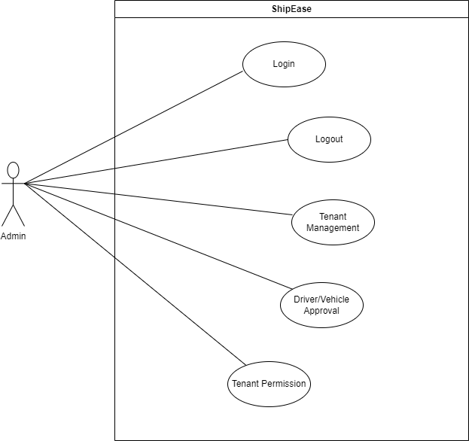

## 

## Tenant:

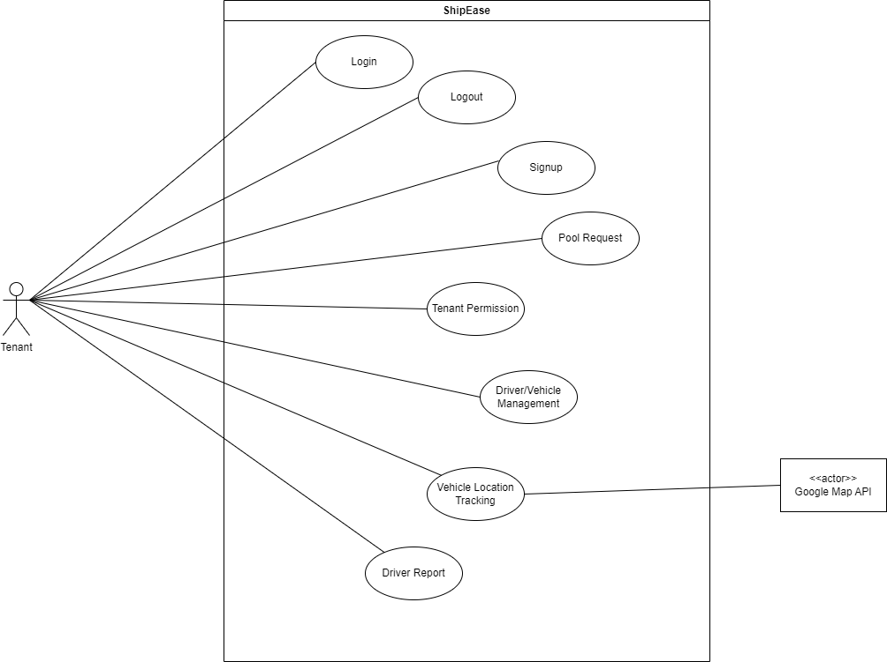

## User:

## 

## 

## Driver:

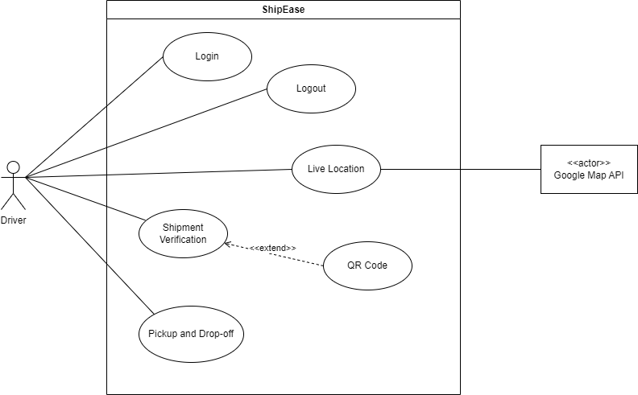

# Expanded Use Cases:

|  |  |  |  |
| --- | --- | --- | --- |
| **Use Case ID** | UC-01 | | |
| **Use Case** | Tenant Management | | |
| **Description** | Admin manages tenant accounts by providing and handling tenant details, and the system ensures completeness and validation of the information. | | |
| **Primary Actors** | Admin | | |
| **Pre-Condition** | Admin is logged in. | | |
| **Post-Condition** | Operations are performed on a tenant account. | | |
| **Main Success Scenario** | 1. Admin select to perform operations on tenants. | 2. The system presents a form for entering tenant details, including personal information and services preferences | |
| 3. Admin provides tenant details. | 4. The system validates the information. | |
|  | 5. System create, reads, updates, or deletes the tenant accounts. | |
| **Alternative Flow** | 1. Admin provides incomplete or invalidated information. | | 2. System prompts admin to provide complete or valid information. |

|  |  |  |  |
| --- | --- | --- | --- |
| **Use Case ID** | UC-02 | | |
| **Use Case** | Driver/Vehicle Approval | | |
| **Description** | Admin reviews and approves or rejects driver/vehicle registration. Admin is responsible for verifying driver documentation and inspecting vehicles. | | |
| **Primary Actors** | Admin | | |
| **Pre-Condition** | Admin is logged in. | | |
| **Post-Condition** | Drive/Vehicle are approved by admin. | | |
| **Main Success Scenario** | 1. Admin navigates to the ‘Driver/Vehicle Approval’ section. | | 2. System displays a list of pending driver/vehicle approval section. |
| 3. Admin reviews the provided documentation, including licenses, insurances, and vehicle inspection report. | | 4. System presents the documentation for admin review. |
| 5. Admin decides to either approve or reject the driver/vehicle. | | 6. System prompts admin to select approval or rejection. |
| 7. If approved, admin selects approve option. | | 8. System updates the status of the driver/vehicle to approved. |
|  | | 9. System notifies relevant parties, including driver and tenant. |
| 10. If rejected, admin selects reject option. | | 11. System updates the status of the driver/vehicle to rejected. |
|  | | 12. System notifies the respective driver or tenant. |
| **Alternative Flow** | 1. Admin notices incomplete or inaccurate documentation. | 2. System prompts admin to request additional information from the driver or tenant. | |
| 3. Admin requests additional information. | 4. System notifies the driver or tenant to provide additional information. | |

|  |  |  |
| --- | --- | --- |
| **Use Case ID** | UC-03 | |
| **Use Case** | Driver/Vehicle Management | |
| **Description** | The tenants use the 'Driver/Vehicle Management' feature to update or change information relevant to the registered drivers and vehicles. They view, select, and manage driver and vehicle records. | |
| **Primary Actors** | Tenant | |
| **Pre-Condition** | Tenant is logged in. | |
| **Post-Condition** | Driver/Vehicle information is created, read, updated, and deleted as required. | |
| **Main Success Scenario** | 1. Tenant accesses the ‘Driver/Vehicle Management’ session. | 2. System displays the list of registered drivers and vehicles. |
| 3. Tenant views the list of registered drivers and vehicles. | 4. System presents the list of drivers and vehicles for tenant review. |
| 5. Tenant selects a driver/vehicle to perform operations. | 6. System highlights the selected driver/vehicle for tenant action. |
| 7. Tenant performs desired operations on the selected driver/vehicle. | 8. System prompts tenant to select an action to be performed. |
| 9. Tenant updates driver/vehicle information or adds new driver/vehicle records. | 10. System updates the driver/vehicle information as per tenant’s actions. |
| **Alternative Flow** | 1. Tenant notices errors in the data input during creation or updates. | 2. System provides error messages indicating the issues in data input. |
| 3. Tenant cancels the operation. | 4. System keeps the driver/vehicle information unchanged. |
| 5. If deleting, the system asks the for confirmation before the operation is completed. | 6. System prompts tenant to confirm the deletion of the selected driver/vehicle. |
| 7. Tenant confirms the deletion. | 8. System removes the selected driver/vehicle from the records. |

|  |  |  |
| --- | --- | --- |
| **Use Case ID** | UC-04 | |
| **Use Case** | Pool Request | |
| **Description** | Tenant uses the Pool Request feature to optimize shipment management by collaborating with fellow tenant(s) who have complementary shipment needs. | |
| **Primary Actors** | Tenant | |
| **Pre-Condition** | Tenant is logged in. | |
| **Post-Condition** | Collaborating tenants agree on terms, and the collaborative shipment proceeds. | |
| **Main Success Scenario** | 1. Tenant navigates to the ‘Pool Request’ feature in the dashboard. | 2. System presents the ‘Pool Request’ feature on the dashboard. |
| 3. Tenant selects ‘Create Pool Request’. | 4. System opens a form for the tenant to fill in pool request details. |
| 5. The tenant provides details of the pool request, including shipment information and available space in their vehicle. | 6. System prompts tenant to enter pool request details. |
| 7. The tenant specifies preferred collaboration terms (e.g., cost-sharing) | 8. System allows tenant to define collaboration terms. |
| 9. The tenant posts the pool request. | 10. System confirms the submission of the pool request. |
| 11. The system displays the pool request to other registered tenants within the network. | 12. System notifies other tenants about the new pool request. |
| 13. Other tenants review the pool request and can accept collaboration. | 14. System presents the pool request to other tenants for review. |
| 15. Incase of acting on the pool request, the system notifies the posting tenant. | 16. System notifies the posting tenant when other tenants show interest. |
| 19. Once an agreement is confirmed, the posting and collaborative tenant confirm within the system. | 20. System facilitates confirmation of collaborative terms. |
| 21. The system generates notifications and updates for all parties. | 22. System sends notifications to all parties about the collaboration agreement. |
| 23. The posting tenant and collaborating tenant(s) proceed with the collaborative shipment based on the agreed terms. | 24. System allows parties to proceed with the collaborative shipment. |
| **Alternative Flow** | 1. If no other tenant expresses interest in collaboration, the posting tenant can choose to edit or cancel the pool request. | 2. System provides options to edit or cancel the pool request. |
| 3. If agreement cannot be reached during negotiations, the collaboration may be canceled. | 4. System allows cancellation of collaboration if agreement cannot be reached. |

|  |  |  |  |
| --- | --- | --- | --- |
| **Use Case ID** | UC-05 | | |
| **Use Case** | Shipment Verification | | |
| **Description** | The registered driver can also use the video capture or QR codes on the mobile application for tracking and recording things loaded in trucks or heavy vehicles. It ensures safe and transparent conveyance of goods. | | |
| **Primary Actors** | Driver | | |
| **Pre-Condition** | Driver is registered. | | |
| **Post-Condition** | Shipment security is ensured. | | |
| **Main Success Scenario** | 1. A registered driver uses the mobile application to initiate shipment loading. | 2. System prompts the driver to initiate shipment loading. | |
| 3. The system provides options for shipment verification such as video capturing or QR code scanning. | 4. System presents options for shipment verifications | |
| 5. The driver initiates video capturing or QR code scanning to record the items being loaded onto the vehicle. | 6. System captures video or scans QR code for verification. | |
| 7. The system start stores the video capturing or QR code scanning and link it to the corresponding vehicle. | 8. System stores the verification data and links it to the vehicle record. | |
| **Alternative Flow** | 1. If shipment verification fails to proceed, the system will prompt the driver to initiate verification again. | | 2. System notifies the driver to retry shipment verification. |

|  |  |  |  |
| --- | --- | --- | --- |
| **Use Case ID** | UC-06 | | |
| **Use Case** | Payment | | |
| **Description** | Tenants securely make online payments using the integrated Stripe API. The process involves selecting the 'Online Payment' option, entering payment details, and receiving a confirmation with a transaction ID. | | |
| **Primary Actors** | Tenant | | |
| **Pre-Condition** | Tenants are registered. | | |
| **Post-Condition** | Online payment is completed. | | |
| **Main Success Scenario** | 1. Tenant proceeds to make a payment for a service. | 2. System loads the payment interface. | |
| 3. The tenant selects the ‘Online Payment’ option for the specific service. | 4. System prompts the tenant to choose the payment method. | |
| 5. The system presents a secure payment gateway for the tenant to enter payment details. | 6. System displays the secure payment gateway for the tenant. | |
| 7. Tenants enter payment information, including credit card details or other payment methods. | 8. System collects and encrypts the payment information. | |
| 9. The system validates the payment details and checks for authorization. | 10. System verifies the payment information with the payment processor. | |
| 11. Upon successful validation, the system processes the payment securely using the Stripe API. | 12. System securely processes the payment using the integrated Stripe API. | |
| 13. The system updates the payment status for the respective service to ‘Completed’. | 14. System confirms the completion of the payment process. | |
| 15. The tenant receives a payment confirmation along with a transaction ID. | 16. System generates and sends a payment confirmation email or notification to the tenant with the transaction ID. | |
| **Alternative Flow** | 1. If payment details are incomplete or authorization fails, the system prompts the tenant to correct the information or use an alternative payment method. | | 2. System displays an error message and prompts the tenant to correct the payment details or choose another payment method. |

|  |  |  |  |
| --- | --- | --- | --- |
| **Use Case ID** | UC-07 | | |
| **Use Case** | User Booking Methods | | |
| **Description** | Users choose from three distinct booking methods, facilitating seamless bilty and shipment bookings based on their preferences. | | |
| **Primary Actors** | User | | |
| **Pre-Condition** | User is registered. | | |
| **Post-Condition** | Booking is confirmed. | | |
| **Main Success Scenario** | 1. User selects to make a booking. | | 2. System loads the booking interface. |
| 3. The user has three booking methods to choose from:  · Dimension-based.  · Vehicle Selection  · Direct Tenant Booking | | 4. System displays three booking methods: Dimension-based, Vehicle Selection, and Direct Tenant Booking. |
| 5. For Dimension-based, the user specifies attributes of the items to be shipped. | | 6. System prompts the user to enter the attributes of the items to be shipped. |
| 7. The system suggests suitable vehicles and tenant options based on the provided attributes. | | 8. System recommends suitable vehicles and tenant options based on the specified attributes. |
| 9. User selects the desired options and proceeds to book. | | 10. System allows the user to select the desired options and proceed with the booking process. |
| 11. For vehicle selection, the user directly chooses a vehicle from a list, viewing associated prices and tenant options. | | 12. System provides a list of vehicles with associated prices and tenant options for the user to choose from. |
| 13. User selects the vehicle and proceeds with booking. | | 14. System confirms the vehicle selection and allows the user to proceed with the booking. |
| 15. For direct tenant booking, the user selects a tenant from a list, reviews their services, and books services directly. | | 16. System provides a list of tenants with their services for the user to choose from. |
| 17. User enters booking details for the shipment to be booked. | | 18. System prompts the user to enter booking details for the selected booking method. |
| 19. The system confirms the user booking, updates the booking status, and provides booking details to the user. | | 20. System confirms the booking, updates the booking status, and provides booking details to the user. |
| **Alternative Flow** | 1. If the user booking is incomplete, the system prompts the user to enter correct or complete information before confirming the booking. | 2. System displays an error message and prompts the user to enter correct or complete information before proceeding with the booking. | |

# Swimlane Diagram:

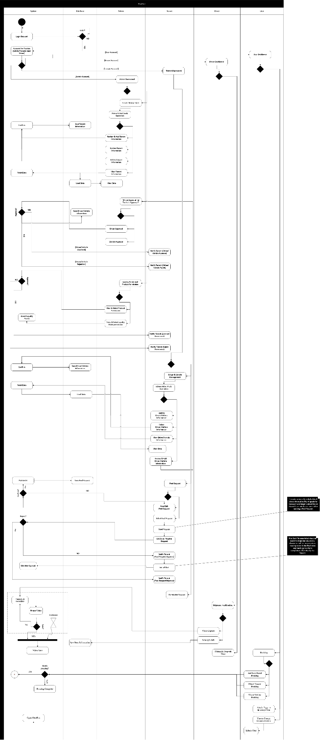

# System Sequence Diagram(SSD):

## Driver Approval:

## 

## Vehicle Approval:

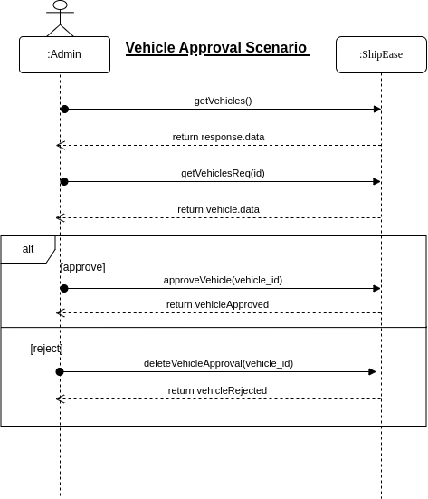

## Driver Management:

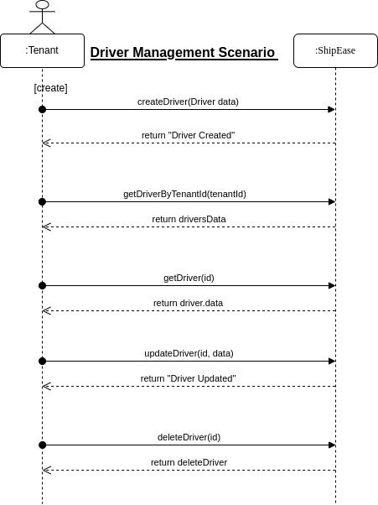

## Vehicle Management:

## 

## 

## Pool Request:

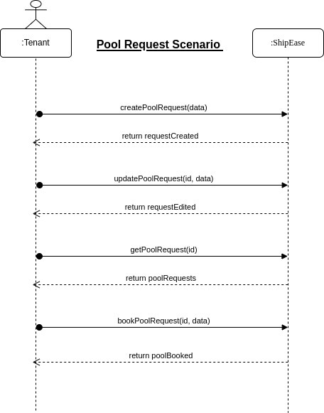

## 

## Tenant Management:

## 

## Booking:

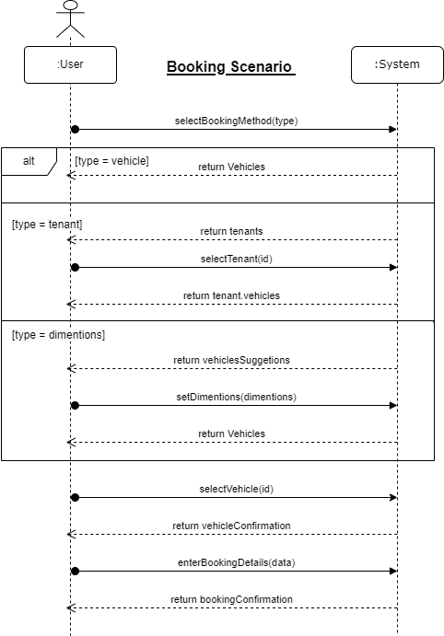

## Payment:

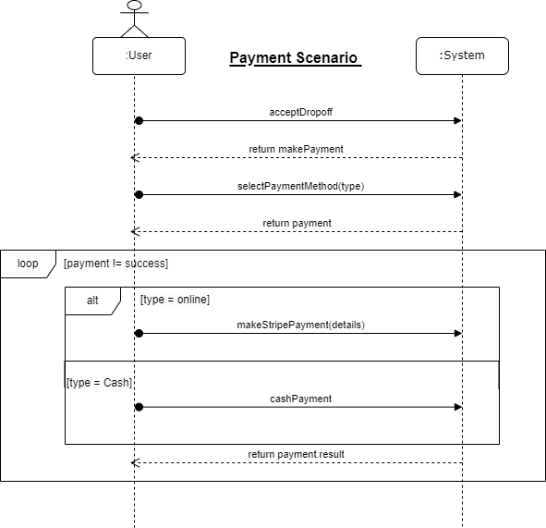

# DFD:

## DFD Level 0:

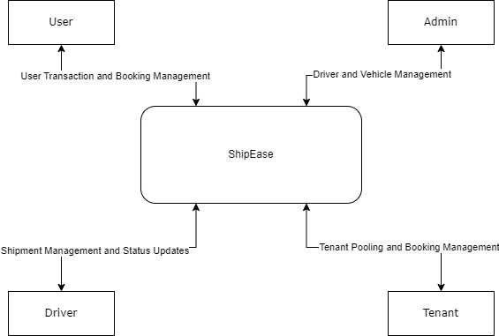

## DFD Level 1:

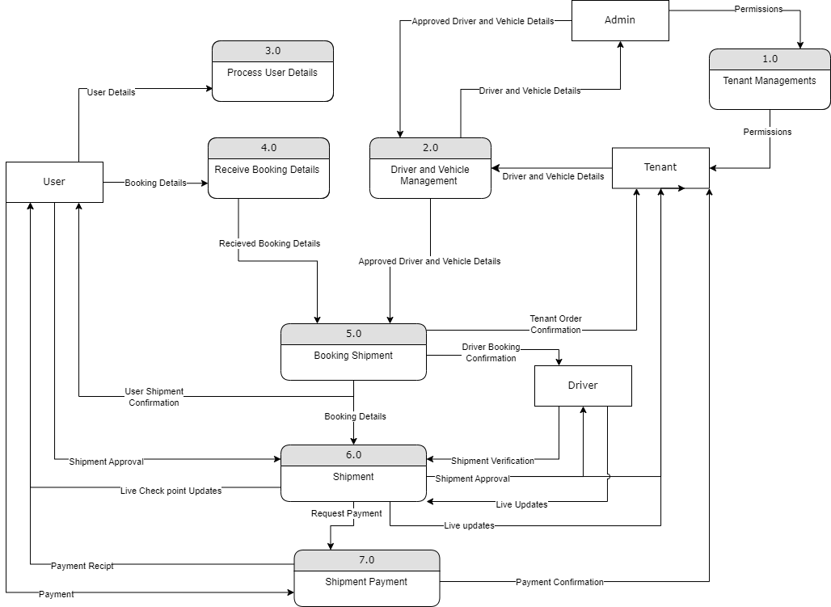

## DFD Level 2:

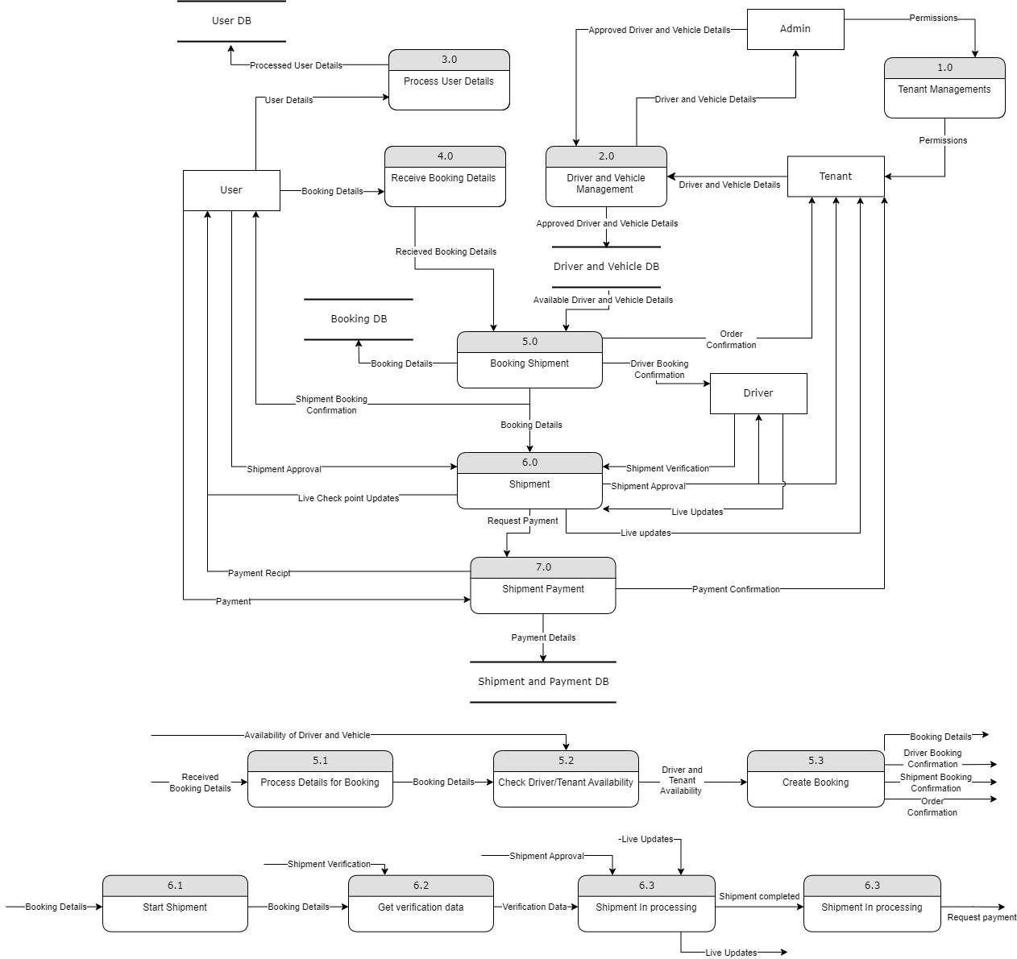

# 

# Schema Diagram:

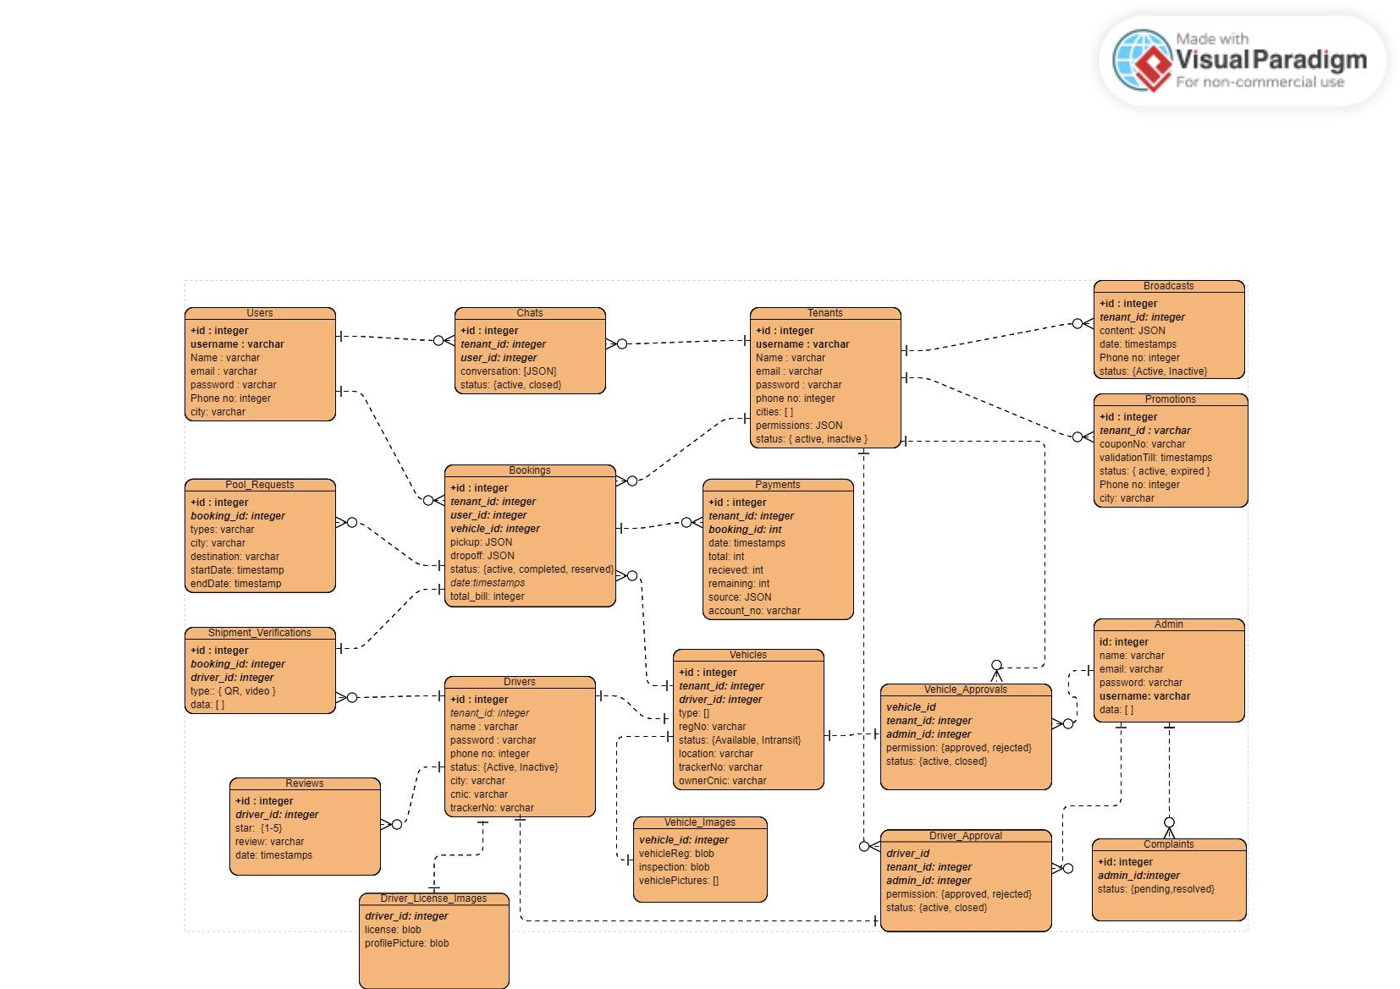

# Layer Diagram:

